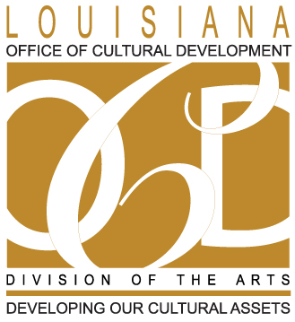

LOUISIANA STATE ARTS COUNCIL
MEETING NOTICE AND AGENDA

State Library Seminar Center
701 North 4th St.
Baton Rouge, LA 70802-5232
Phone: 225-342-4948

Friday, February 6, 2014
2 p.m. – 3:30 p.m.

- Call to Order and Welcome

- Approval of Minutes (July meeting)

- Chairman’s Report

- LDOA Director’s Report

- LDOA Staff Reports
        - Grant-making
        - Cultural Districts
        - Folklife
        - Percent for Art
        - Arts-in-Education

- LPA/LCA Report

- New Business

- Public Comment

- Adjournment

